Week 2

1. What are the softwares that help to run Java programs?
The main software required for developing and running Java programs are JDK, JRE and JVM. An IDE such as Eclipse or NetBeans can also be used to write, compile and run Java programs easily.
JDK (Java Development Kit): Used for developing Java programs.
JRE (Java Runtime Environment): Provides the environment to run Java programs.
JVM (Java Virtual Machine): Executes Java bytecode.
IDE(Integrated Development Environment): Helps in writing, debugging and running programs.

2. What is JDK and JRE?
JDK (Java Development Kit)
JDK stands for Java Development Kit. It is a software package used to develop, compile, debug, and run Java programs. It contains the Java compiler (javac), JRE, JVM, and other development tools such as the debugger and documentation tools. JDK is mainly required by Java developers for creating and testing Java applications.

JRE (Java Runtime Environment)
JRE stands for Java Runtime Environment. It provides the environment required to run Java programs on a computer. It contains the JVM (Java Virtual Machine) and the required Java class libraries and supporting files. JRE is mainly used for executing Java applications, but it does not contain development tools such as the Java compiler.

Difference between JDK and JRE:
JDK is used to develop and run Java programs.
JRE is used to run Java programs.
JDK contains JRE and development tools.
JRE contains the JVM and Java libraries required for execution.

3. What is Eclipse IDE?
Eclipse IDE is an Integrated Development Environment used mainly for developing Java applications. It provides facilities for writing, compiling, running and debugging Java programs. It also helps in managing projects, classes and files easily.

4. How to run the Java program in Eclipse/NetBeans IDE?
The following steps are used to run a Java program:
1. Install the JDK on the computer.
2. Open Eclipse/NetBeans IDE.
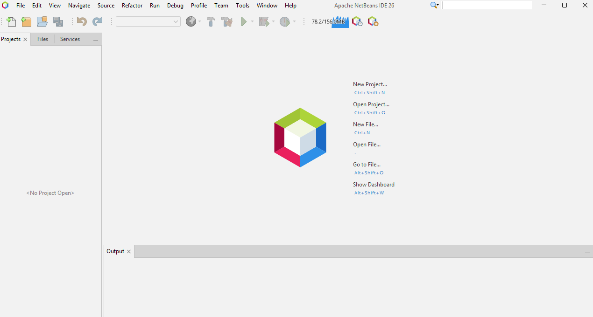

3. Create a new Java project.

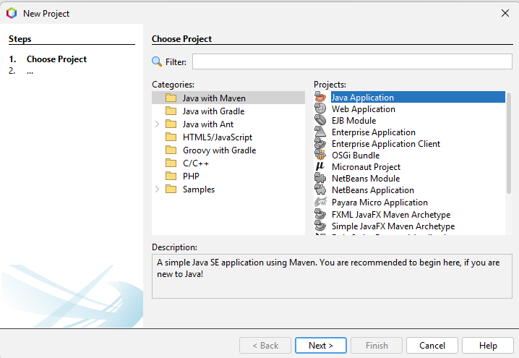
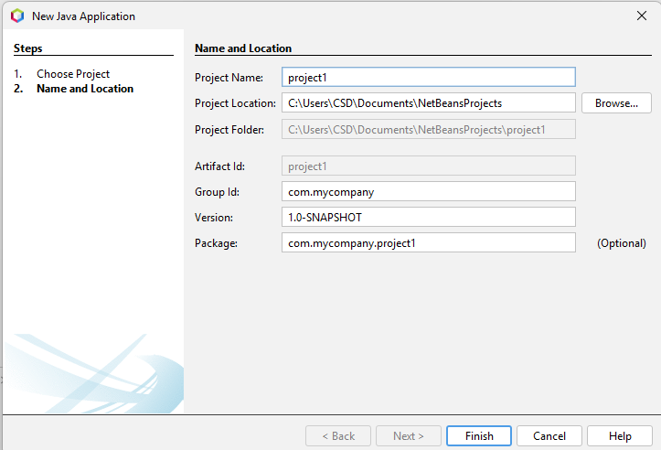

4. Create a Java class inside the project.
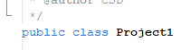
5. Write the Java program in the class.
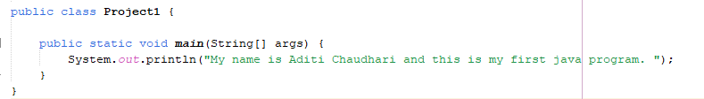
6. Save the program.
7. Click on the Run option.
8. The output will be displayed in the Console/Output window.
